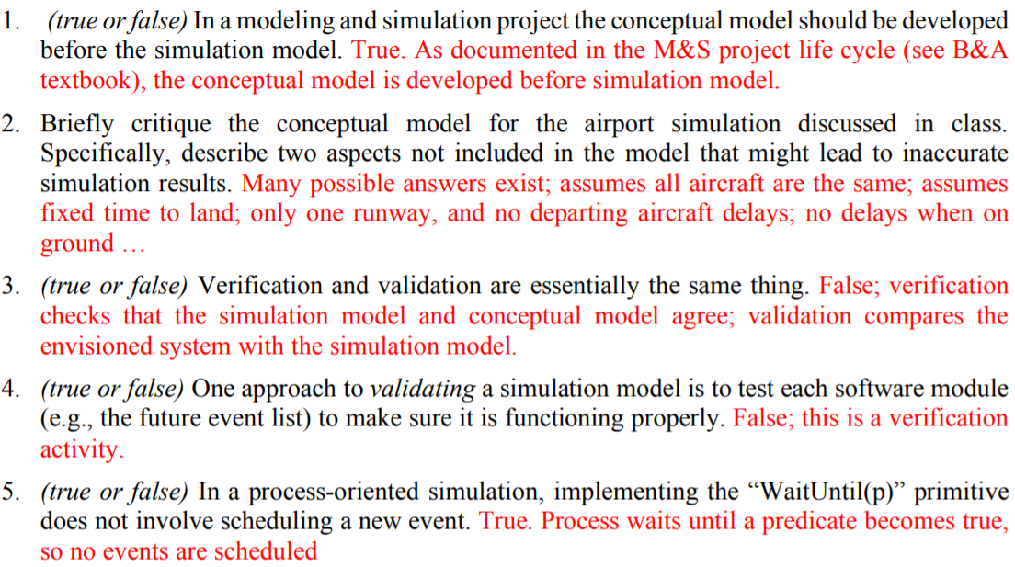

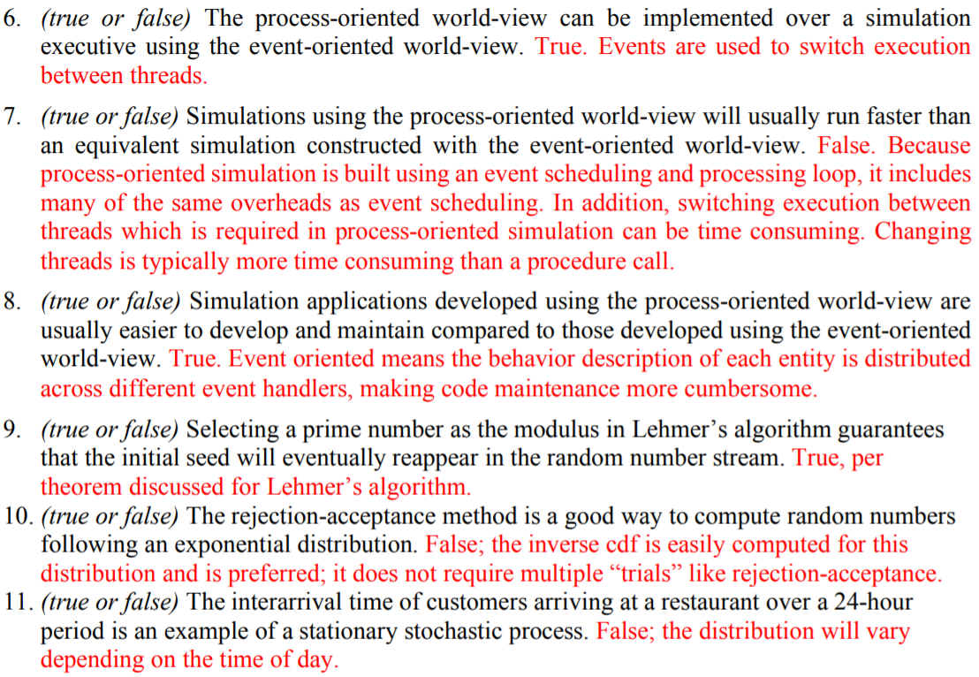

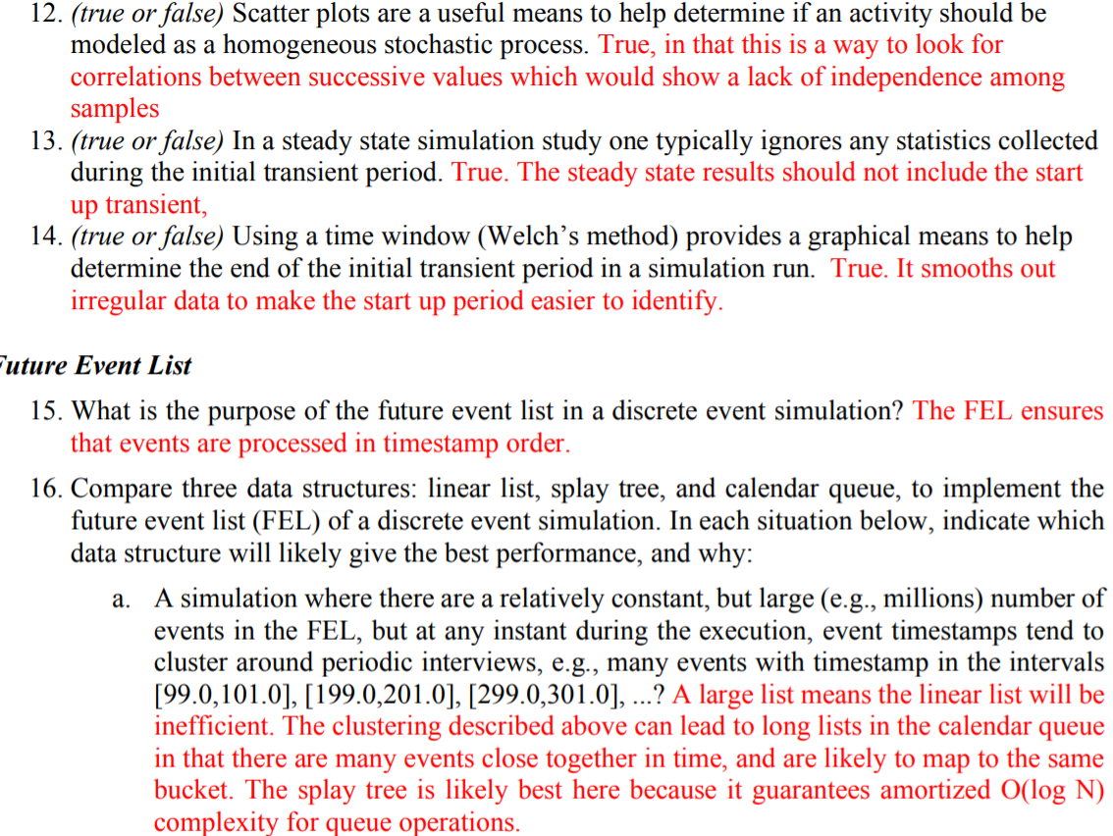

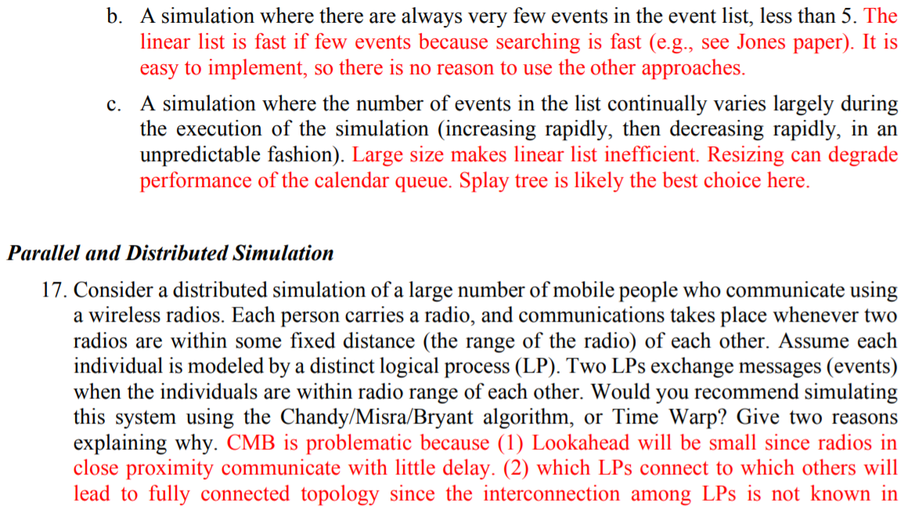

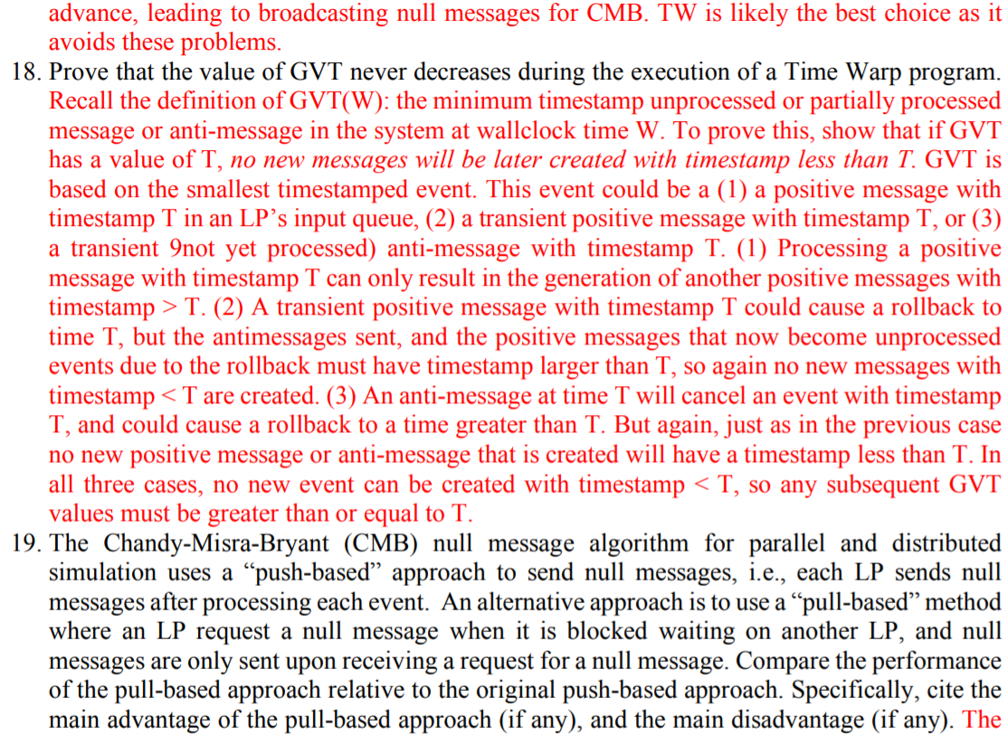

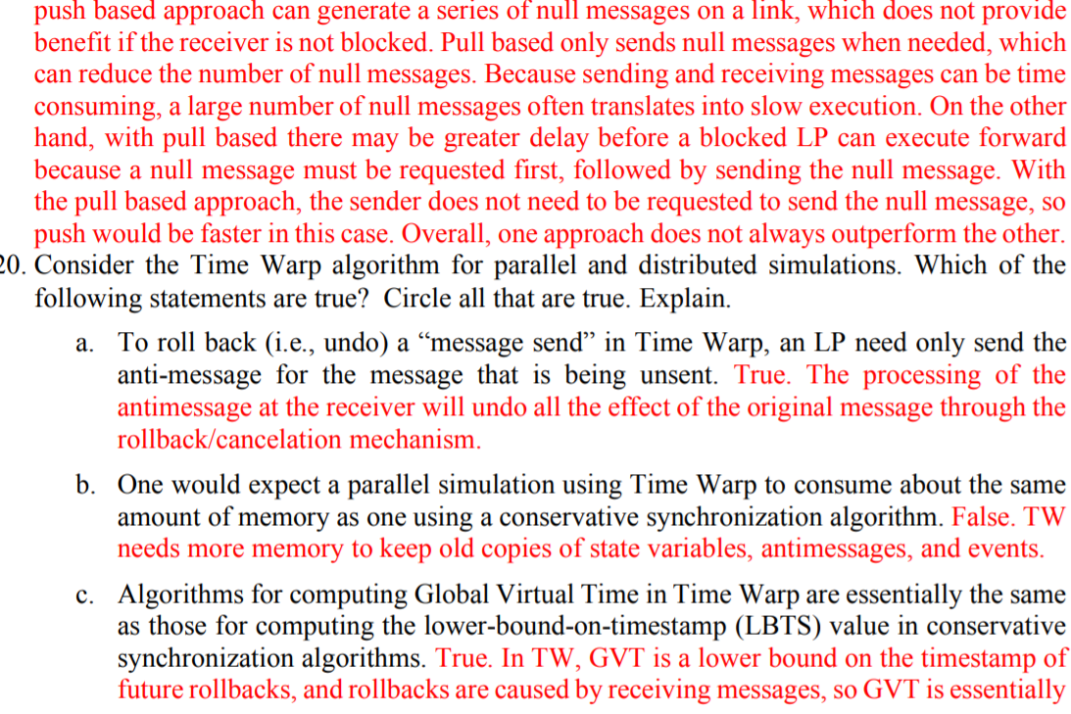

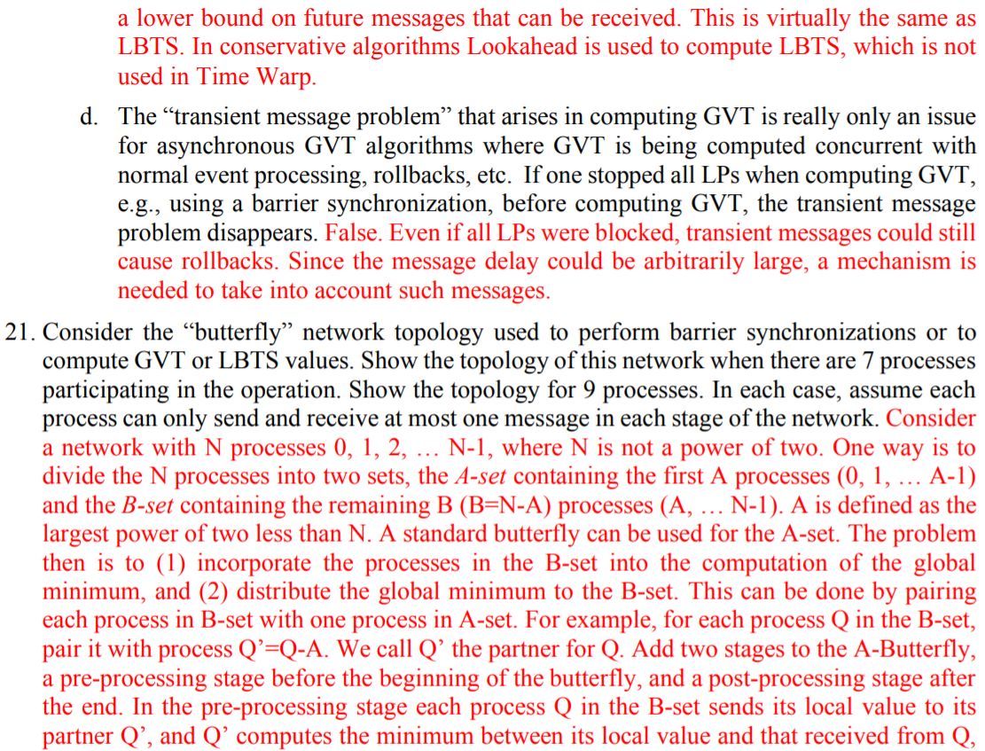

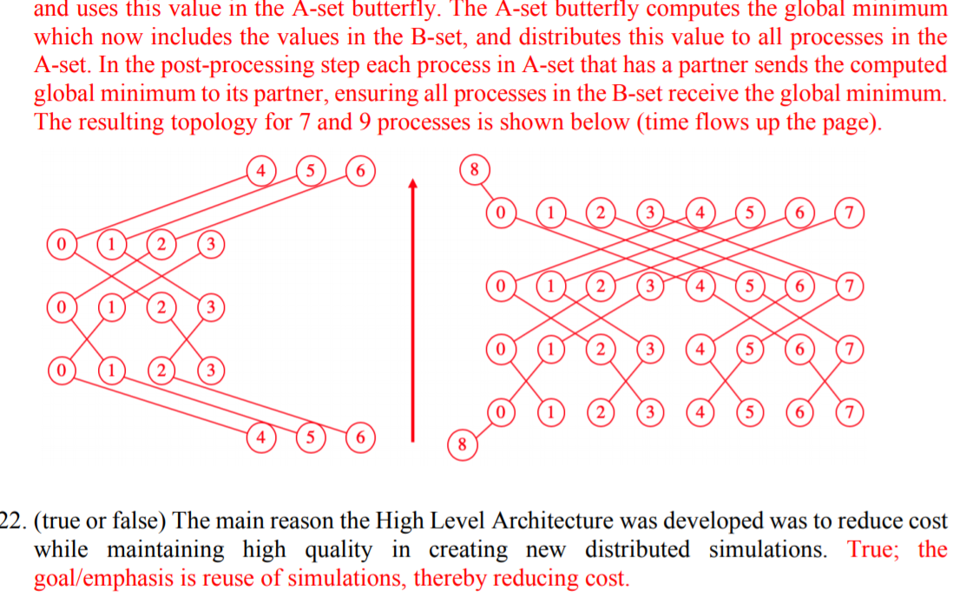

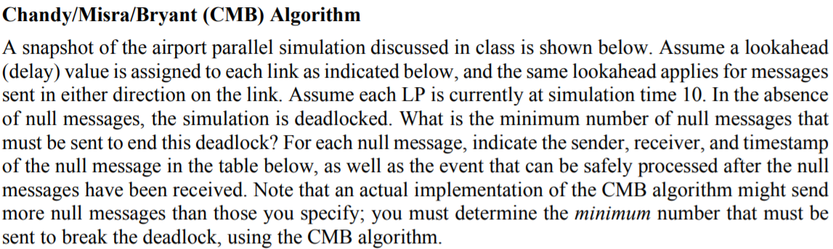

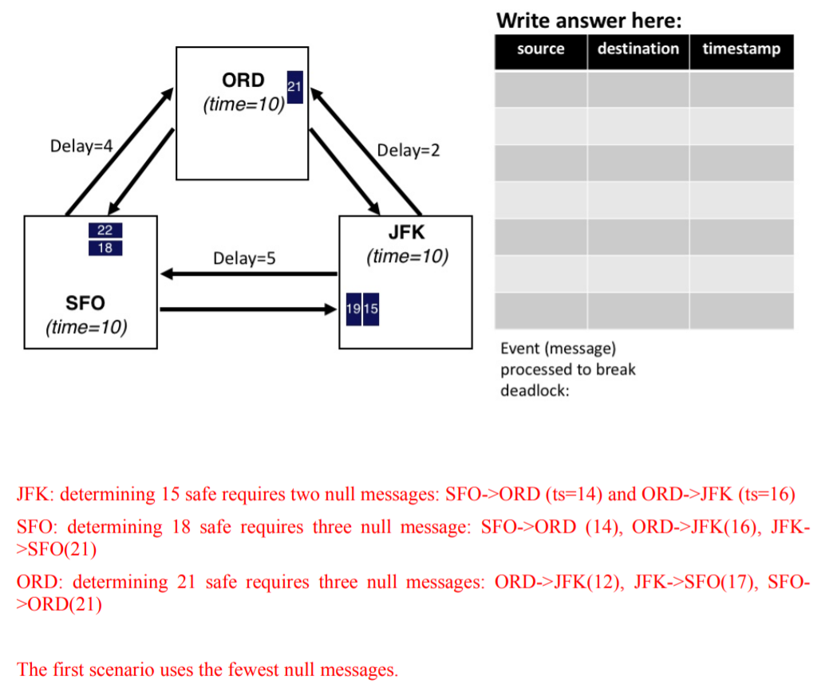

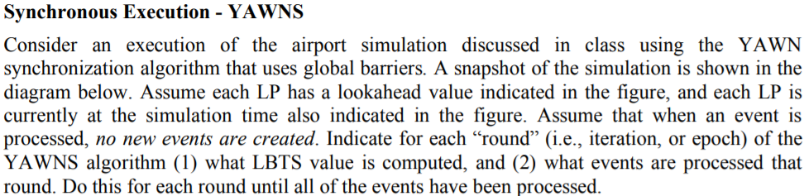

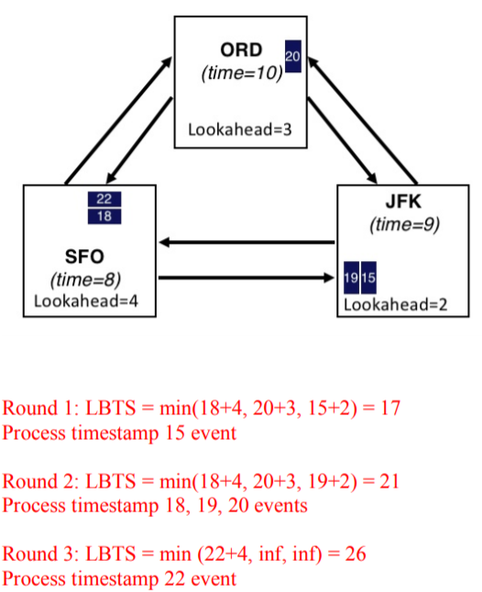

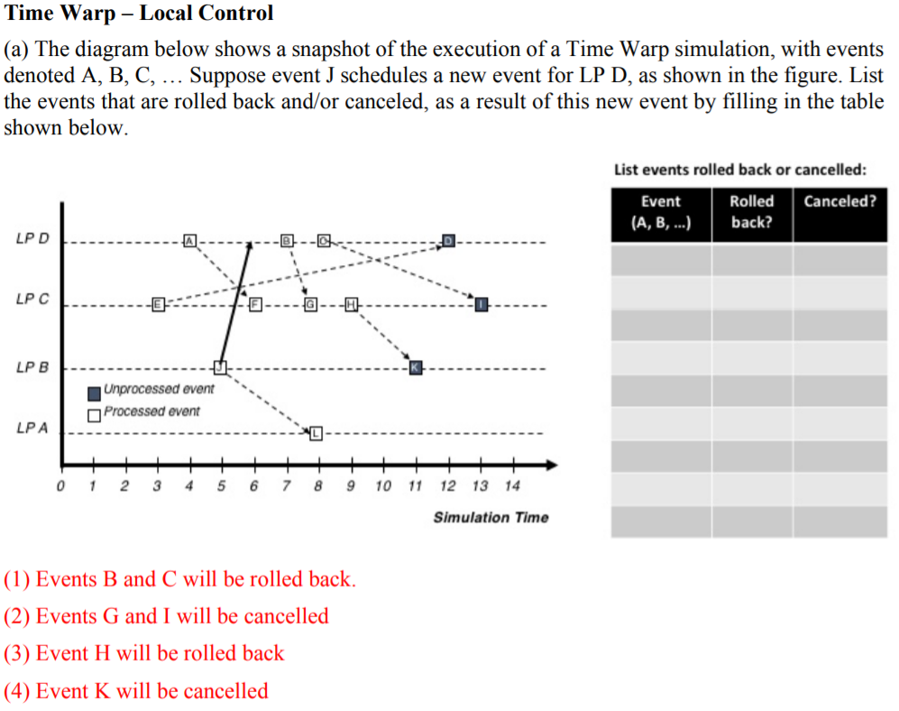

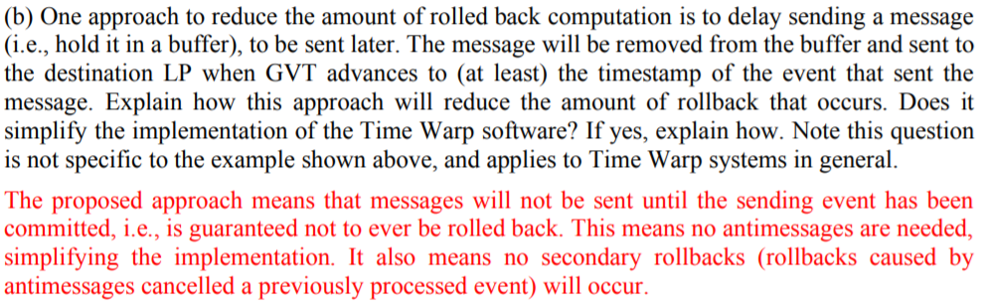

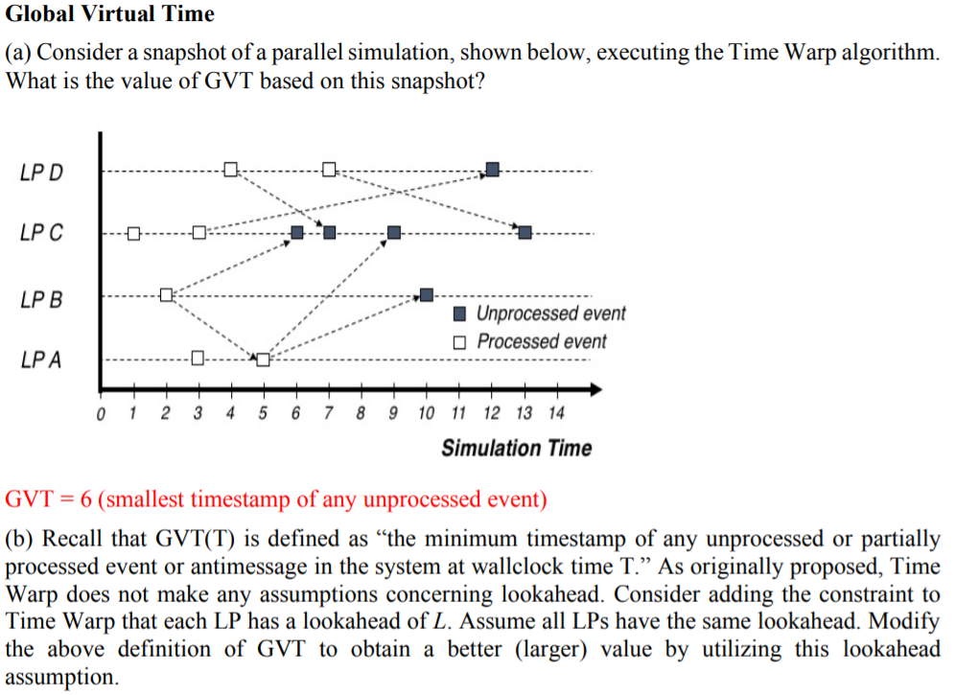

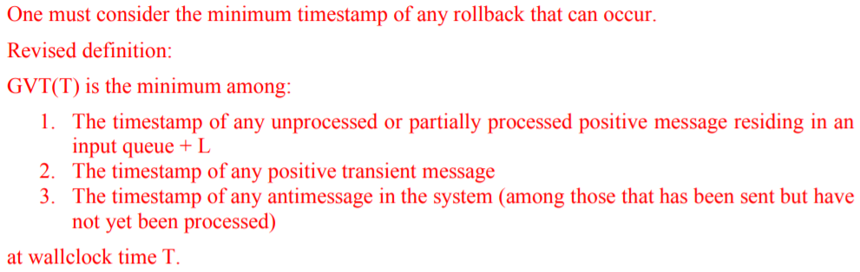

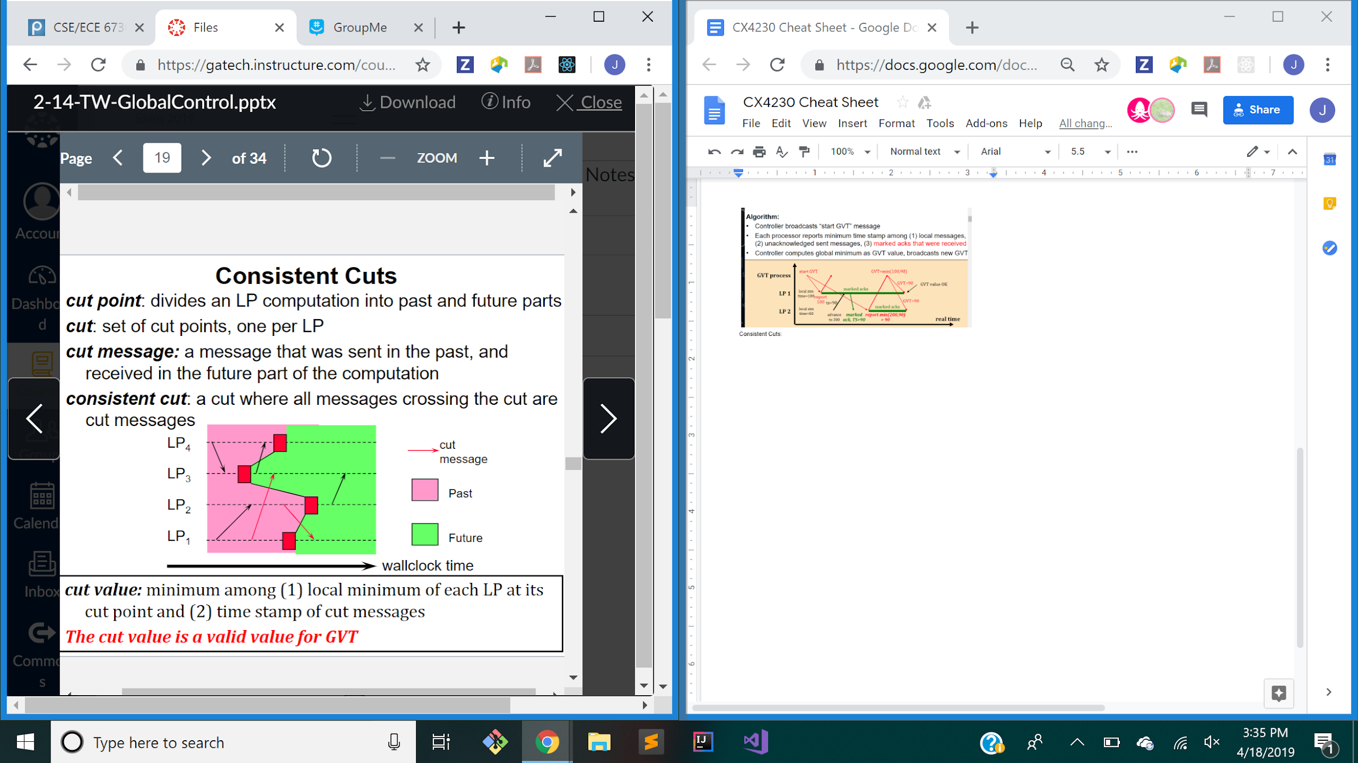

Computing GVT with consistent Cuts:

Any LP initiates a GVT operation

Sends current color and count (red sent - red recieved), and mintime (minimum unprocessed message timestamp)

Receive GVT message: If first GVT variable -> initialize variables (above)

All LPs perform reduction:

MinTimei=min(Min local time, GVT_TIME)

Counti = local count + GVT_COUNT

Send new GVT mesage to partner in butterfly

Transient Cut Message: If global count is not 0, retry GVT

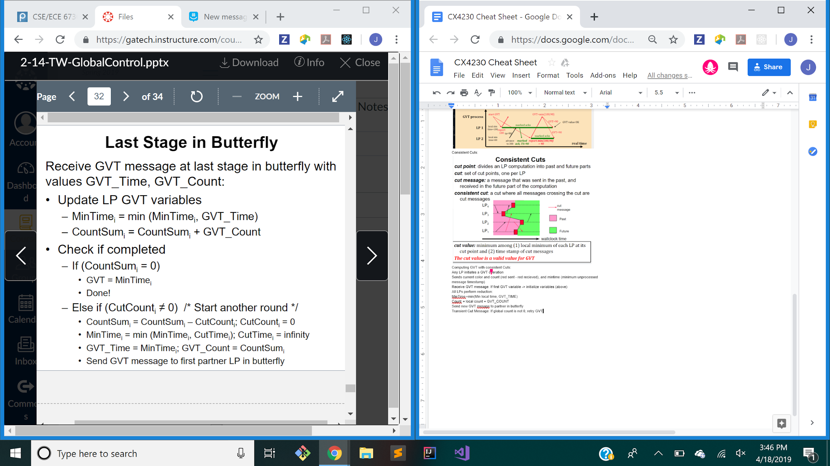

Performance Bounds: Minimum execution time = critical path length (length of longest path through dependency graph)

Average parallelism = (number of nodes/LPs) / (critical path length

